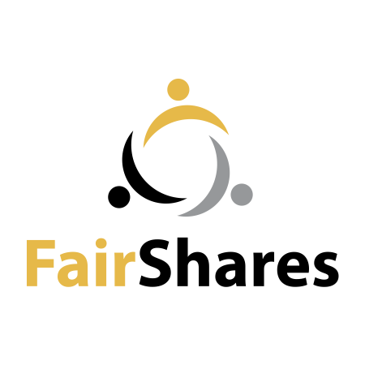
FairShares Canvass V3.0
CQ = Canvass Question, KQ = Key Question
Relevance (for Idea workshops) | Feasibility (for Incubation workshops) | Sustainability (for Planning workshops)

What is your idea?  (General value proposition)  (CQ1.1 / KQ2)  What need(s) does your idea fulfil? (Primary purpose)  (CQ1.2 / KQ2)  What makes your idea attractive:  (Stakeholder value propositions)  - To those who will start the enterprise (Founder members)? (CQ1.4 / KQ2)  - To those who will make the goods/services offered by the enterprise (Labour members)? (CQ1.5 / KQ2)  - To those who will use / buy goods / services from the enterprise (User members)? (CQ1.6 / KQ2)  - To those who will contribute money  (Investor members)? (CQ1.7 / KQ2) |  | How would you describe (label) your primary stakeholders?  (Link to learning activity about primary stakeholders)  Founders:  (CQ2.1 / KQs 1 and 4)  Labour member:  (CQ2.2 / KQs 1 and 4)  User members:  (CQ2.3 / KQs 1 and 4)  Investor members:  (CQ2.4 / KQs 1 and 4) | What goods/services can you offer to achieve your primary purposes?  (Key activities)  (CQ2.10 / KQ3) |  |  | How will you segment users (i.e. clients/customers)?  (Market segments)  (CQ3.3/ KQ5)  (Link to learning activity on markets / market segmentation)  How will you reach each segment?  (Distribution channels)  Direct  (CQ3.4 / KQ5)  Via Partners/Intermediaries  (CQ3.5 / KQ5) |  | How will primary stakeholders review the following type of impact:  (Social auditing)  Social impact on members  (CQ3.5 / KQ6)  Economic impacts on members and host community  (CQ3.7 / KQ6)  Environmental impact  (CQ3.8 / KQ6)
 |  | How can primary stakeholders cooperate to create a supply chain?  (Production > Consumption)  Directly  (CQ2.11 / KQs 1 and 4)  Via Partners/Intermediaries  (CQ2.2 / KQ4) | What resources / assets do you need to make them?  (Key assets)  (CQ3.1 / KQ5)

How does your idea create opportunities to share power and wealth?  (CQ1.3 / KQ1)  Surplus % to reserves (CQ2.5 / KQ1):  Remaining surplus / power sharing %  Founders: (CQ2.6 / KQ1)  Labour: (CQ2.7 / KQ1)  Users: (CQ2.8 / KQ1)  Investors: (CQ2.9 / KQ1) |  | What wealth will you use up (natural, human, social, intellectual, manufactured, financial capital)?  (Cost structure / Social-environmental costs)  (CQ3.2 / KQs 3 and 5)  (Link to learning activity about different types of capital) |  | What wealth will you create (natural, human, social, intellectual, manufactured, financial capital)?  (Revenue streams / Social-environmental wealth)  (CQ3.9 / KQ6)  (Link to learning activity about different types of capital)
FairShares Canvass V3.0

Final Questions
CQ4.1 - Are there any other questions we need to ask/answer during the planning workshops?

CQ4.2 - Are there any tax laws that might influence the choice of legal form?

CQ4.3 - Are there any cultural / legal barriers to registering as a company, cooperative, partnership or association?

CQ4.4 - What is the 'qualifying contribution' for Labour members (i.e. What labour contribution is sufficient to be accepted as a Labour member)?

CQ4.5 - What is the 'qualifying contribution' for User members (What use or purchase of enterprise goods/services is sufficient to be accepted as a User member)?

CQ4.6 - Should this FairShares Plan be published?

